Photography Release Form

Photo Release
I __________________________________ hereby authorize Kamau Brothers to use photographs of me taken by Kamau Brothers (Photographer) for the purpose of exhibit, promo, print, publication, reproduction and social media or advertising.
I affirm that I or my legal guardian is of legal age and have the right to agree with the terms of this release.

Printed Name: _________________________
Signature: __________________________
Address: _____________________________________________________________________
_____________________________________________________________________
Phone: ________________________ Cell: ________________________
Email: _________________________
Date: ________________________

If under 18:
Parent Name/Legal Guardian: _____________________________________________________
Relationship: __________________________________________________________________
Parent/Legal Guardian Signature: __________________________________________________
Phone Number: _____________________
Date: _________________________

Photographer Info:
Name Printed: Kamau Brothers
Signature: 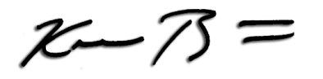
Phone Number: 210-309-0623
Website: www.KamauBrothers.com
